Newborn screening for scid

“State of the Art”
It is more than 10 years since the inclusion of SCID within the Recommended Uniform Screening Panel in the USA.
During that time much has been learned and a number of countries have now begun to evaluate, operate or plan newborn screening programmes.
On January 26th and 27th 2021 we are pleased to host a virtual meeting of leaders in the field from around the world to discuss progress.
You can register for this meeting at:
https://membership.isns-neoscreening.org/member/conferences/

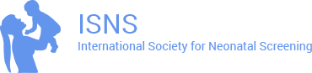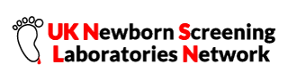
26th & 27th January 2021
The meeting will begin each day at 14.00 (UK time) and will close at around 18.00 (UK time)
It will include live interaction and Q&A and attendance certificates of Continuing Professional Development will be issued to registrants
The registration fee for the one day meeting is : 25 GBP or 30 Euro payable to ISNS:
https://membership.isns-neoscreening.org/member/conferences/
Contact J.Bonham@nhs.net or peter.schielen@gmail.com for details and gaelle.notzli@mci-group.com for conference logistics

